Guidance: Font: Century 9 point. Maximum of one page with photos and graphics. Headings are provided as a guide – they can be used as is or tailored to suit your corporate branding/reporting.

ABOUT [Member name]
Insert a description of your organisation – core business, locations, and services provided.

ROLE IN BATTERY STEWARDSHIP
Insert a description and photos or graphics

History
Insert a description of the history or your organisation and include photos or graphics where possible.

Commitment to Sustainability

Insert a description with photos if possible describing your contribution to sustainability.

Why Does XXX VALUE BEING an ABRI member?

Insert a statement that describes why being a member of ABRI is of value to your organisation.

CORPORATE PROFILE
Ownership
Phone |  | Website

ABRI’s Vision
ABRI’s vision is to achieve battery stewardship in Australia by:

- Advocating for a national battery recycling scheme,
- Developing and promoting best practices for battery collection and recycling, and
- Creating opportunities for information exchange, collaboration, and policy development.

At the forfront
ABRI is at the forefront of industry research and development in Australia and internationally. In addition to having a strong membership base in Australia, ABRI is connected to key players in Europe and the US, enabling us to stay current with the latest policy and best practices.

Our membership is pursuing innovative solutions to battery stewardship, including scheme design, packaging options, best practice guidelines, and analysis of emerging sectors such as fire safety and energy storage.

ABRI Members
ABRI members represent the spectrum of players in the battery life-cycle, including manufacturers, importers, energy storage providers, retailers, recyclers, government agencies, and non-profit organizations.

It is this diverse membership that is our strength in that it provides us with a broad perspective on the challenges and opportunities facing battery stewardship in Australia.

INDUSTRY VOICE
ABRI is regularly in conversation with industry stakeholders, as well as local, state and federal government, to increase awareness of the industry’s concerns and to pursue proactive realistic solutions for improved recovery. We provide input both at the strategic level for creating a national scheme for recycling batteries and at the tactical level in designing best practices for battery collection and recycling.

Together, we influence policy, participate in research, and facilitate trials to ensure that battery handling and recovery options are safe, efficient and business friendly

ABRI Members

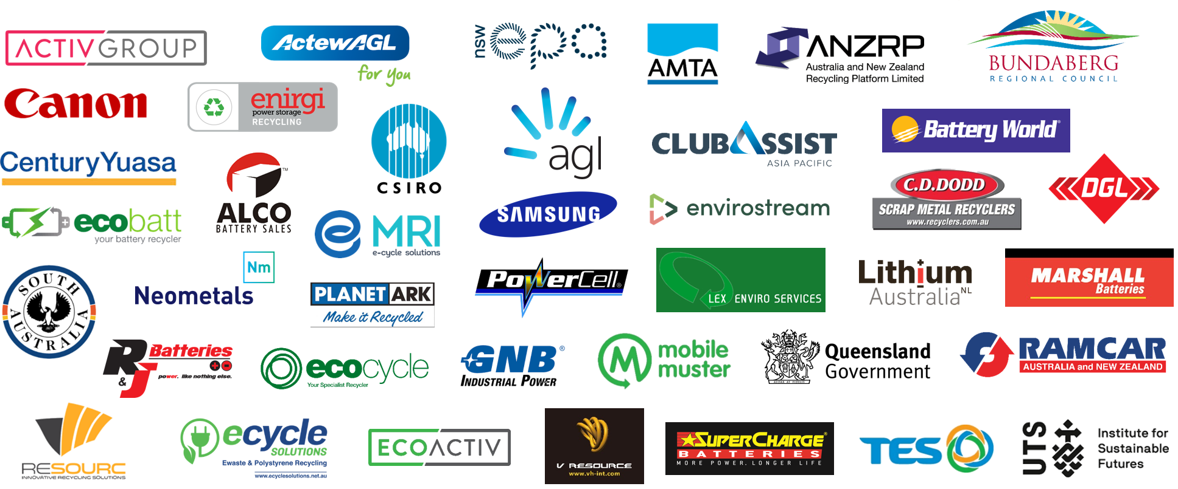

Join us today!
For more information about how to become a member, go to: www.batteryrecycling.org.au

